Fiber Optic Cabling Toolkit 12-1070

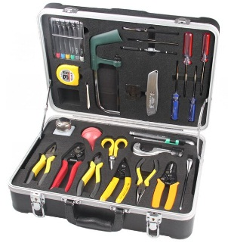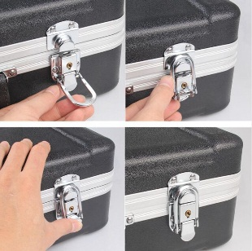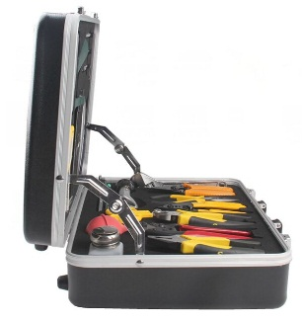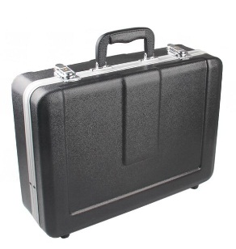

Main Features:

- Toolkit ideal and utility for optical fiber cable construction
- It is widely used in optical fiber fusion splicing / termination work and maintenance for fiber optic telecommunication.
- It includes all kinds of the most frequent used tools which cut kevlar and slit jacket
- 26 items including Heavy ABS carrying case
- Most of the hand tools are necessary for optical fiber fusion splicing

Standard Package:

No. | Item name | QTY | Unit
1 | 6PCS Electronic Screwdriver Set | 1 | pc
2 | Measuring Tape(3.5m) | 1 | pc
3 | Mini Hack Saw | 1 | pc
4 | Cleaning Swab 25 PCS Package | 1 | bag
5 | Mid-Span Jacket Slitter | 1 | pc
6 | Carbide Fiber Scribe | 1 | pc
7 | Fiber Optic Tweezer 259 | 1 | pc
8 | Mark Pen | 1 | pc
9 | Precision Art Knife,FO-4009 | 1 | pc
10 | Parallel Tip Screwdriver, (-)5*150MM | 1 | pc
11 | Crosspoint Screwdriver, (+)#5*150MM | 1 | pc
12 | Parallel Tip Screwdriver, (-)6*150MM | 1 | pc
13 | Crosspoint Screwdriver, (+)#6*150MM | 1 | pc
14 | 9PCS Ball-Point Hex Key Set BL-229 | 1 | set
15 | Cable Jacket Slitter 4-32mm/ TC-105C | 1 | pc
16 | Adjustable Wrench (8") | 1 | pc
17 | Jacket Stripper | 1 | pc
18 | Fiber Optic Kevlar Cutter, KS-1 Miller | 1 | pc
19 | Fiber Optic Stripper, CFS-2 | 1 | pc
20 | Long Nose Plier(6 '')(150mm) | 1 | set
21 | Steel Wire Cutter(6'')(158mm) | 1 | pc
22 | Diagonal Cutting Plier | 1 | pc
23 | Optical Cable Wire-cutter Ac-8 | 1 | bag
24 | Dust blowing balloon | 1 | pc
25 | BottleLeak proof alcohol bottle, ABP-100ML | 1 | bag
26 | ABS Heavy Duty Tool Case (430*340*130mm | 1 | bag

